LAB 4

1. While tcpdump host your_host is running in one command window, run ping 127.0.0.1 from another command window. From the ping output, is the 127.0.0.1 interface on? Can you see any ICMP message sent from your host in the tcpdump output? Why?

$ sudo tcpdump host 172.16.59.27

=> Cannot see the icmp packets sent from host using loopback address since it is used for testing and it never enters the network. To view these packets, ‘lo’ is used in the next command with loopback address. The interface is set to ethernet. A loopback is created but listening is on the hardware level and the packets never cross the physical ethernet interface. Instead, they stay within the operating system's networking stack.
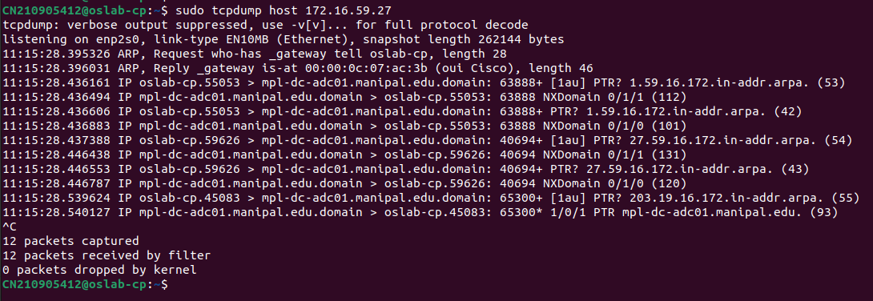
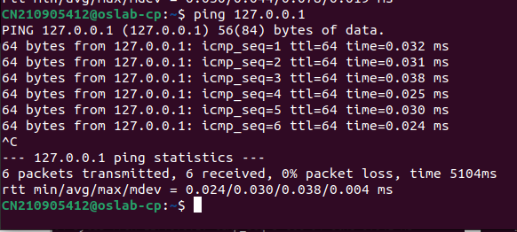

$ sudo tcpdump -i lo host 127.0.0.1 -w q1
ICMP echo request and reply messages can be seen since the interface is set to loopback.

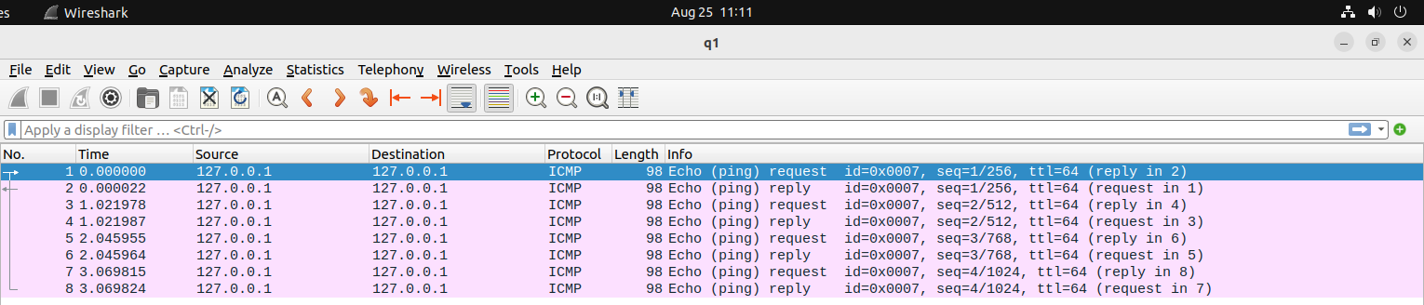
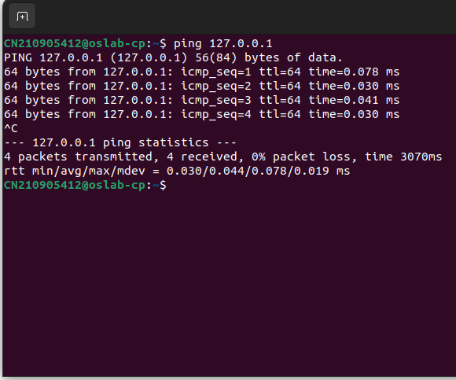
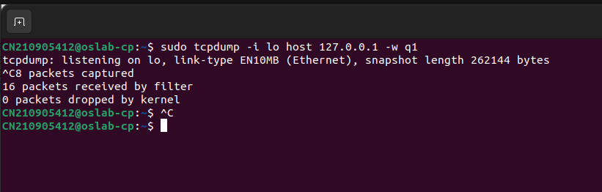

2. While tcpdump host your_host is running to capture traffic from your machine, execute telnet 128.238.66.200 or ping 172.16.59.251. Note there is no host with this IP address in the current configuration of the lab network. Save the tcpdump output of the first few packets. After getting the necessary output, terminate the telnet/ping session. From the saved tcpdump output, describe how the ARP timeout and retransmission were performed. How many attempts were made to resolve a non-existing IP address?

$ sudo tcpdump host 172.16.59.27 -w q2 $ ping 172.16.59.251 -c 1

=> There is no host with the ip address 172.16.59.251 in the current configuration of the lab network. (Using ping instead of telnet)

When pinging a non-existing IP address, ARP (Address Resolution Protocol) tries to find the MAC address associated with that IP. It sends an ARP Request, but since the IP doesn't exist, no response is received. After a certain time (ARP timeout), the system considers the request unanswered and retries a few times (ARP retransmission) depending on the operating system's configuration and timeout settings. Since no response is received, it marks the ARP resolution as unsuccessful. This process helps determine whether a host is reachable on the local network.

Three attempts were made to resolve the non-existing IP address.

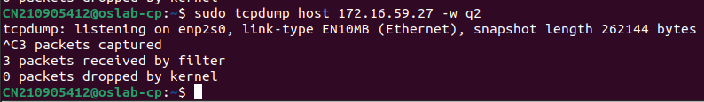
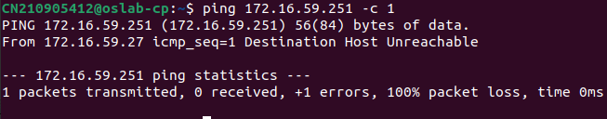

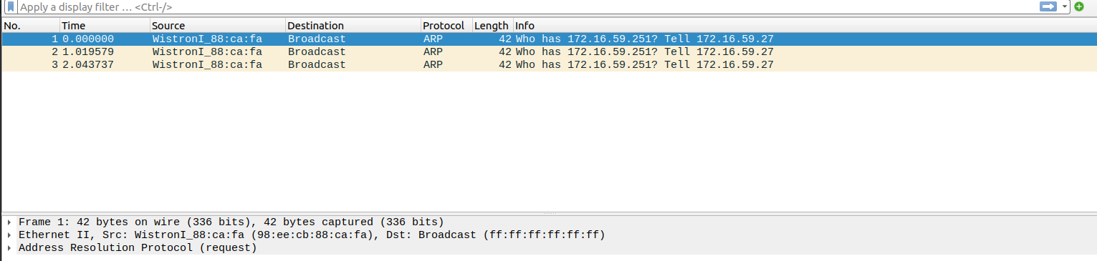

3. Briefly explain the purposes of the following tcpdump expressions.

a. tcpdump udp port 520 : Captures UDP packets that have a source or destination port number of 520 (associated with the Routing Information Protocol (RIP), used for routing information exchange in networking).

b. tcpdump -x -s 120 ip proto 89 : Captures IP packets with protocol number 89 ( corresponds to the OSPF (Open Shortest Path First) protocol, which is used for routing and exchanging link-state information in IP networks). The -x flag displays packet data in hexadecimal and ASCII format, and -s 120 captures up to 120 bytes of each packet.

c. tcpdump -x -s 70 host ip addr1 and (ip addr2 or ip addr3) : Captures packets involving ip addr1 and either ip addr2 or ip addr3. The -x flag displays packet data in hexadecimal and ASCII format, and -s 70 captures up to 70 bytes of each packet. It allows monitoring of traffic between ip addr1 and either ip addr2 or ip addr3.

d. tcpdump -x -s 70 host ip addr1 and not ip addr2 : Captures packets involving ip addr1 but excludes those involving ip addr2. The -x flag displays packet data in hexadecimal and ASCII format, and -s 70 captures up to 70 bytes of each packet. It allows observation of traffic to and from ip addr1 while excluding traffic involving ip addr2.

4. Basic packet decoding
1) Write a tcpdump command to dump network traffic from an Ethernet connection to the
screen in human readable output format. Perform the following operation and write down
the observations.

$ sudo tcpdump -i enp2s0 -ttttnnvS

-i enp2s0: Specifies the interface to capture traffic from.
-ttttnnvS: Provides human-readable output with detailed information about captured packets.
a) Capture all the traffic of maximum snap length of 65,535 bytes and provide the
hexadecimal and ASCII decodes of all the traffic in each packet.

=> $ sudo tcpdump -xx -s 65535 -i enp2s0 -ttttnnvS

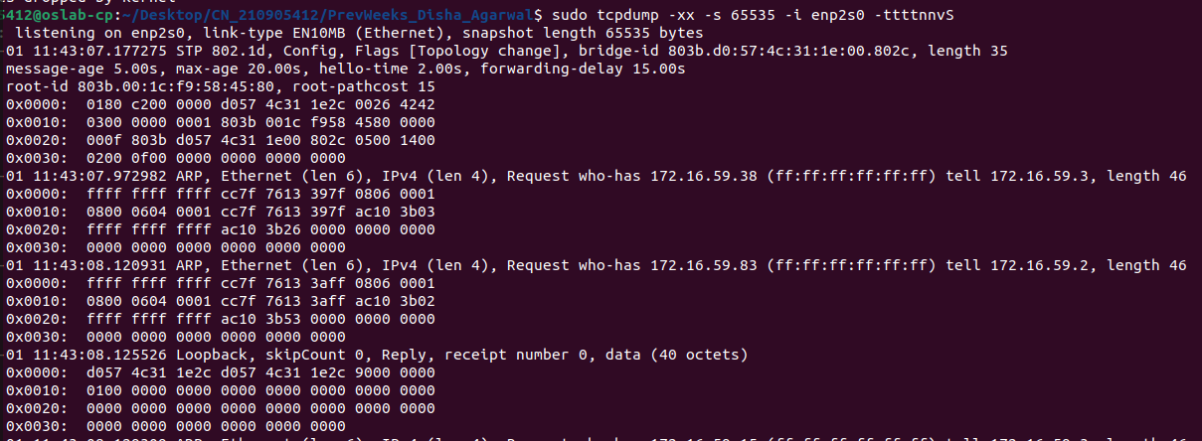

b) Find the IP addresses, IP packet length, TCP port numbers, TCP flags, etc. by using
the reference chart to locate those fields on the hexadecimal dump.

Source IP : 172.16.59.49
Destination IP : 34.120.208.123
IP Packet Length : 60
Source Port : 48178
Destination Port : 443

